Report on Analysis of flipchart Laptops

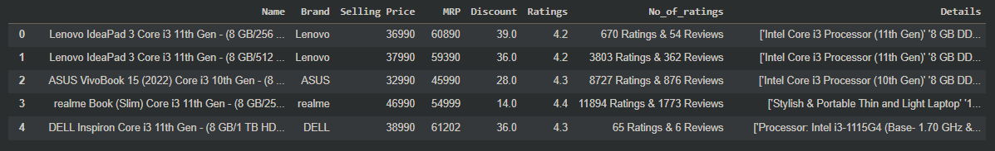

Libraries

1. Pandas
2. NumPy
3. Seaborn
4. Sci kit learn
5. Matplotlib

Model Used: Linear Regression

Model Accuracy: 0.9837974403722146

Count X Laptop Brands graph

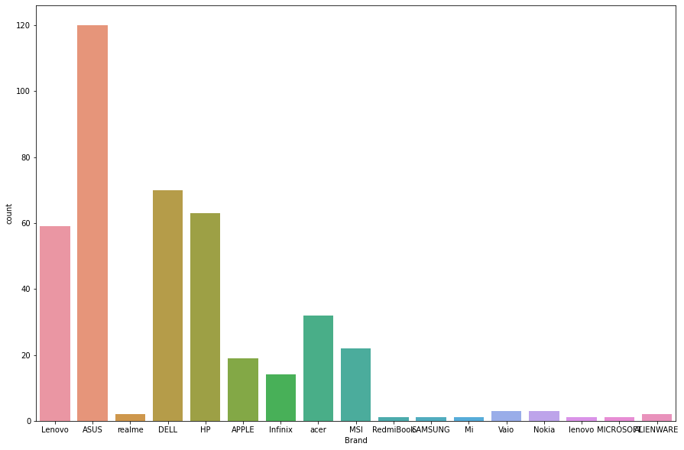

Brands X Selling Price graph

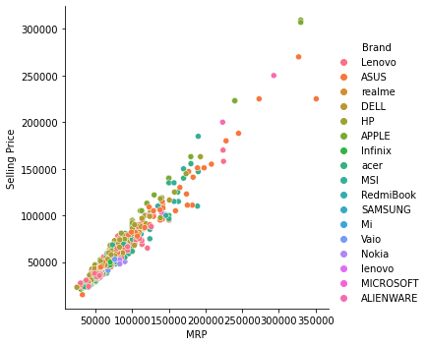

Brand X Ratings trendline

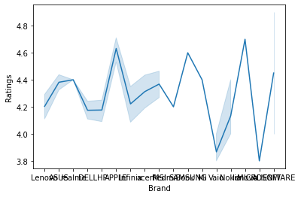

Brand X MRP graph

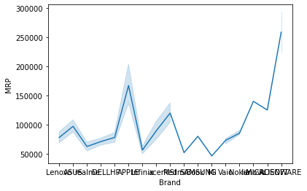

Brand X Selling Price

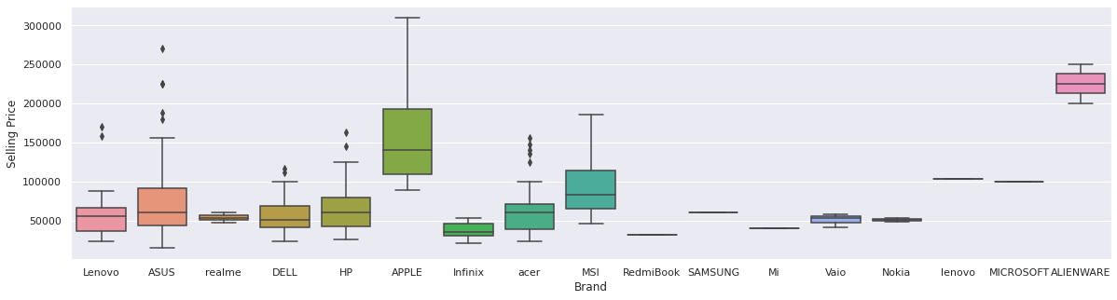

Correlations

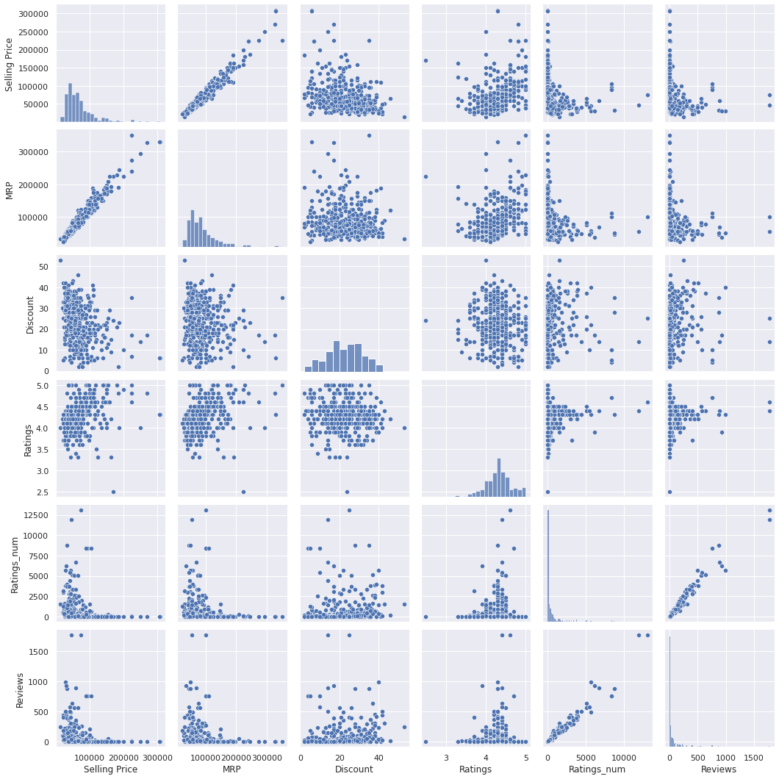

Used label encoder to drop irrelevant columns

